**URARTIAN GOLDS HIDDEN IN NOAH’S ARK?**

70000 legends in 72 languages tell us about a giant flood but scientific findings show no trace of the geological history of the world that the waters rose so high. Mount Ararat has been like pessenger inn for centuries, everyone is after Noah’s Ark.

Marco Polo, İbn Batuta, Evliya Çelebi, Writer Pushkin, Cevdet Sunay (formerpresident of Turkey) , Yaşar Kemal (Turkish famous writer), Ümit Deniz (Turkish Journalist) and Ara Güler (Famous Turkish Photographer) were among those who climbed the mountain in pursuit of the ship.

Since everyone knows the Flood Legend, there is no need to tell about it again. The aim of this article is to understand what we do not know and to draw attention on the subject in different, interesting directions. Could the flood havoc be real? Was the Flood local or did it affect the planet? Who is Prophet Noah? When did the flood happen? On which mountain did Noah's Ark sit after the Flood? Was this mountain Ararat or Cudi? What were the people who had been trying to climb Ararat to find Noah's Ark for centuries, really after? We are looking for answers to these questions…

It is necessary to look at religious sources and even holy books when approaching the Flood, Noah and the Ark legend. The Quran talks about this event at length in many verses. But how? Let's compare a few interpretations together.

Ahmet Halit Bookstore – Tafsir. Omer Rıza Doğrul 1947 Edition, excerpt from the Qur'an commentary called "The Commandment of God"; Page 364 Surah Hud Verse 40

After the water boiled in the valley, the Flood started - Noah took everything with him - His family and believers got on the ship and the ship sat on Mount Judi.

Directorate of Religious Affairs: The Quran 1983 Edition Page 225. Surah Hud-Verse 40: After the water from the tandoor boiled, the Flood began-Noah took couples of all kinds living. His family and believers got on the ship and sat on Mount Judi.

Human Publications - Tafsir El Mawdudi-Tefhimul Kuran Page 368 - Surah Hud -Verse 40: Tennur erupted and the tandoor boiled, the Flood began - Noah took two lives each - His family and believers boarded the ship and sat on Mount Judi. According to the tafsir, the Flood started with the outburst of tennur, the downpours came out from the ground. Heaven and Earth opened, tennur boiled the water, so the Ship is powered by steam. In other interpretations made according to verse 27 of Surah al-Muminun, tennur is the Earth or Fare't tennur is the dawn beat (daybreak). It may be that the water boils, that is, the sky turns red at dawn.

Eren Publications – Tafsir İsmail Hakkı İzmirli - Quran Page 227 Surah Hud Verse 40: When the edict came and the earth boiled, the Flood started – Noah took a pair of each animal – His family and believers boarded the ship and sat on Mount Judi.

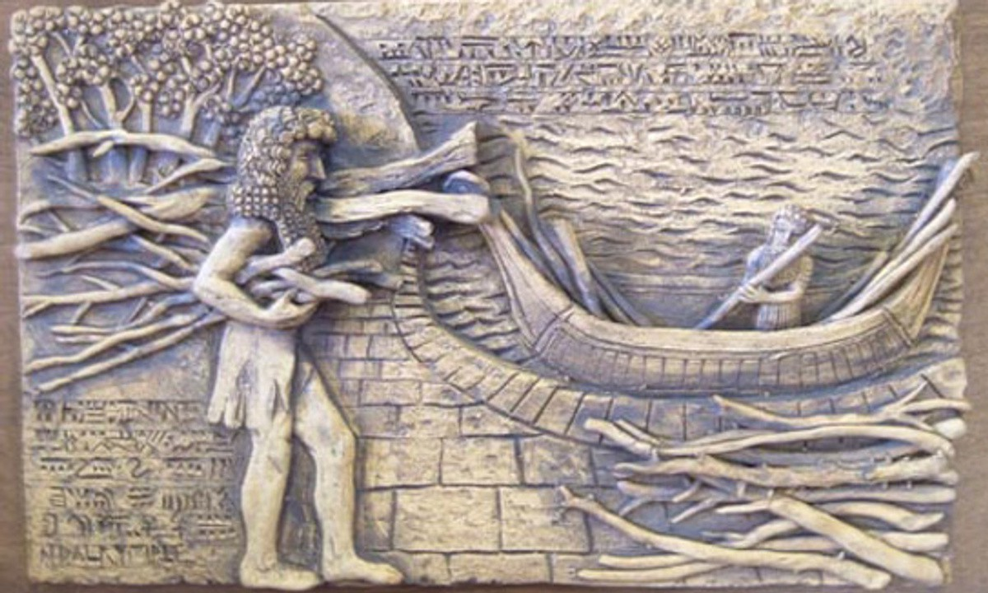

Let's take a see what the Torah says.

**“There will be no more Flood…”**

The Bible Company – The Bible/Old and New Testaments – Genesis Chapter 7 – Noah took one male and seven females from each clean animal and one pair each of the unclean birds, and seven pairs of birds – The Flood began on February 17. It rained for 40 days and the waters rose, and finally the ship swam. It took 150 days for the waters to rise. – On July 17, the ship landed on Mount Ararat. A year later, on February 17, the waters lowered, the land appeared – God said, “…the clouds in the sky will form bows, and I have made a covenant, there will be no more Flood.”

The Epic of Gilgamesh comes first after the holy books in the Flood legends.

Hürriyet Publications - Epic of Gilgamesh 1973 edition. From the noise and confusion of the people, the Gods were disturbed and decided to exterminate the people with the Flood, but God told Eon Utnapishtim (Noah) to build an ark in a dream, announcing the decision. Unapishtim took the seeds of living things and built a 7-deck and 9-chambered ship of equal width. The ship had a captain and the ship was launched. His family, relatives and craftsmen boarded the ship. Unapishtim took their gold with him. There was the helmsman on the ship, and the Ark sat on Mount Nisir after the Flood, and then Enlil, the Exterminatory God, who came to the scent of the deodate, held the hand of Utnapishtim and his wife and made him immortal as a reward for his loyalty to the gods.

Ministry of National Education Publications – Epic of Gilgamesh 1944 Edition – The ship's keel was 3528 meters and its rail was 3 meters. Utnapishtim's lineage and people boarded the ship. He took his gold and silver with him. When the Flood began, the radiance of the Gods dyed the sky red, and when the waters receded the Ark sat on Mount Nissir. The mountain was on the Iraqi-Iranian border. In Syriac Torah, the name of the mountain was Kardo. The god Enlil took the hand of Utnapishtim and his wife and touched their gold, thus making them God.

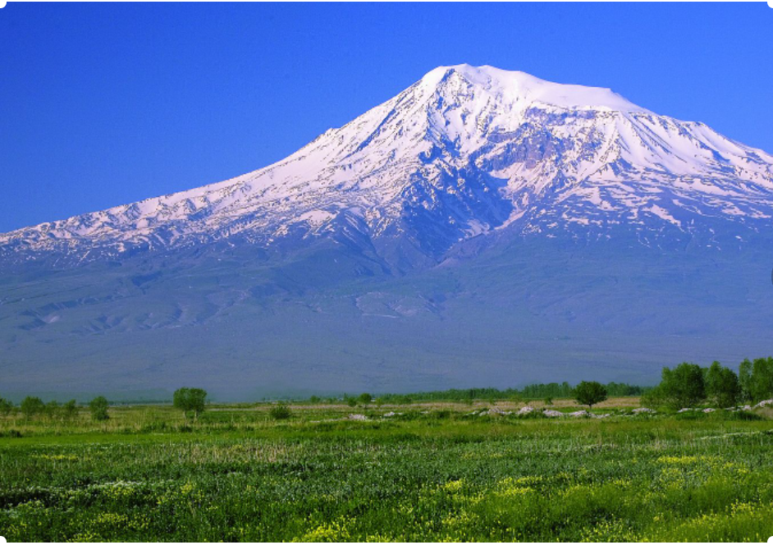

**On which mountain?**

This is how the religious books, which are the main sources about the Flood, and the Epic of Gilgamesh, the most important legend, tell us about the Flood. As seen, there are differences between interpretations. What was the beginning of the Flood? But the most interesting thing is that it is said in Mawdudi's tafsir that "the tandoor has boiled and the ship has moved". So it is an allusion to a steamship, but how could a steamship be in the time of Noah? There are differences in interpretations. The Flood in the Torah is different and detailed, and the narrative of the Flood in the Epic of Gilgamesh are very different. Could the truth be much further away? But first, let's see what the word Flood makes us think about. It is a very old word and has influenced all the languages ​​of the world. Like English “typhoon”, French “typhon”, Chinese “tai-fung” and the word ship crew “tayfa” (in Turkish) derived from them…

Another example of word connections comes from the Torah. According to the book, the ship was made of Gofer wood. It is also called Goffer, and in English the word "coffin" is derived from some kind of basket. (*cophinus)*  According to some legends, Hz. He took Adam's coffin and that's where the link comes from. From all this it can be understood that mystical texts and the myths around them can be complex and sometimes inconsistent. But the only thing is certain that there was a Flood havoc. The question is where and how big…

The debate on whether Noah's Ark is real or not has been going on for many years, of course, together with opposing views.

If the measurements given in the Torah are correct, Noah's Ark is really huge. With today's dimensions, the ship's weight is around 45 to 66 thousands of tons. So with the highest probability Noah's Ark is as big as the Titanic. However, considering the dimensions in the Babylonian Flood inscriptions, the idea of a 228000-ton ship raises, which is not easy to build even today.

There is another estimation about the size of Noah’s Ark; We can fill only half of the ship as big as Titanic if we put a couple of all known land animals aboard and add birds and insects even. So the question “Why half of Noah's Ark is empty?” arises. This answer seems vague. According to the Torah, it has a length of 136 m, a width of 22.5 m, a height of 13.5 m and 3 floors, similar to a chest. And the other chests in the legends immediately come to mind. Noah’s Ark of the Covenant – Just as Utnapishtim emerged from the ark and Romus and Romulus, who founded Rome, were thrown into the river in the ark. Somewhere in the past there is a memory of a mysterious chest, and Daniken inevitably comes to mind. Traditions from the Flood and Noah's ark still continue. For example, Ashura, the ones who get out of the ship and stay on the mountain, this is uncertain for the gods, they mix all the remaining provisions and cook. This is ashura and its date of manufacture is 10 Muharram. Then comes the tradition of Nowruz, which is the first new day after the flood and the greening of nature.

**What Do The Three Great Travelers Say?**

While it is stated in all sources that Noah's Ark sat on Mount Judi, let's examine the events closely in a chronological line, why Mount Ararat gained importance. Throughout history, it is seen that there have been almost countless travelers and researchers describing the relationship between Noah's Ark and Mount Ararat. The first of these is perhaps the famous traveler **Marco Polo**, and he mentions **Mount Baris** or **Olympus** in his world-famous book ‘**travels of Marco Polo** ’. Noah's Ark is there. The name Olympus is only a name given to the holy mountains, so Ağrı is holy, but how? Another great traveler, **Ibn Batuta** from Morocco, writes that the Ark was on Mount Judi and saw the mountain in Cizre. **Evliya Çelebi**, another immortal traveler, author of "Travel", also mentions that the Ship was located on Mount Cudi. All these world-famous travelers wrote and conveyed information gained during their travels to as many as people. Many researchers, inspired by them and later, took the road to Mount Ararat. Let's see this amazing story now.

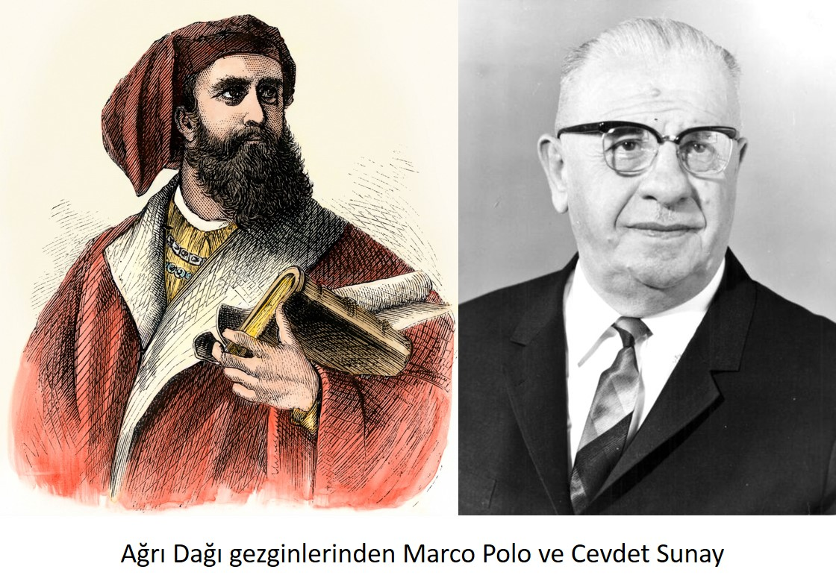

Two of those who were Mount Ararat travellers. Marco Polo and Cevdet Sunay was a former president of Turkey.

**Czar II. Nicholas and Cevdet Sunay**

In 1670, Dutch traveler **Jan Struys** sees a monk in Ağrı. The monk had seen the ship and gotten into it. He presents a cross made from the wood of the ship to the traveller. **French Tavarnier** writes that in the middle of 1600 there is a mention of the Ship in Ararat. While the world-famous Russian writer **Alexandre Pushkin** was describing his journey to Erzurum in the early 1800s, he referred to Ararat - Mount Ararat as the place where Noah's Ark was. In 1829, **German Prof Parrot** gives the same information. It is said that the piece of wood found by a shepherd in 1833 belonged to the Ship. A year later, in 1834, **Russian Spaski** points out Ararat**,** in 1838, the famous **Prussian General Von Moltke** referred to Cudi as the mountain of Noah's Ark. German **Joe Abich** and English **Seymour**, Russian geographer **Khanikoff** and British **Stuart** in 1850 climbed Mount Ararat to find the Ark. In the same years, English mountaineer **Lord Bryce** finds a piece of wood in Ağrı and **Nestorian Priest Nouri** sees the ship, seeks help but dies without success.

In 1888, 1889, 1890, 1892 and 1893, various groups went to Ararat and the 20th century came.

By 1916, Russian Pilot **Roskowitzki** took the stage and took pictures from his plane. There is a ship-shaped image in the photos. He presents these pictures to Czar II. Nicholas. The Czar had been very interested in photographs, but the subject was forgotten and overthrown by the October Russian Revolution.

In 1936, New Zealand mountaineer **Knight** finds pieces of wood on the mountain. After those years, Turkish groups also started to go to the mountain. Cevdet Sunay, who became a Major in 1937 and later the President of Turkey, went to the mountain with a group of 65 people.

In 1948, Reşid and Şükrü Arsena said that they had seen the Ark, but French **Jean de Ringauer**, who beleived in this lie, fails. In 1949, the American, Professor **J. Smith** finds no trace.

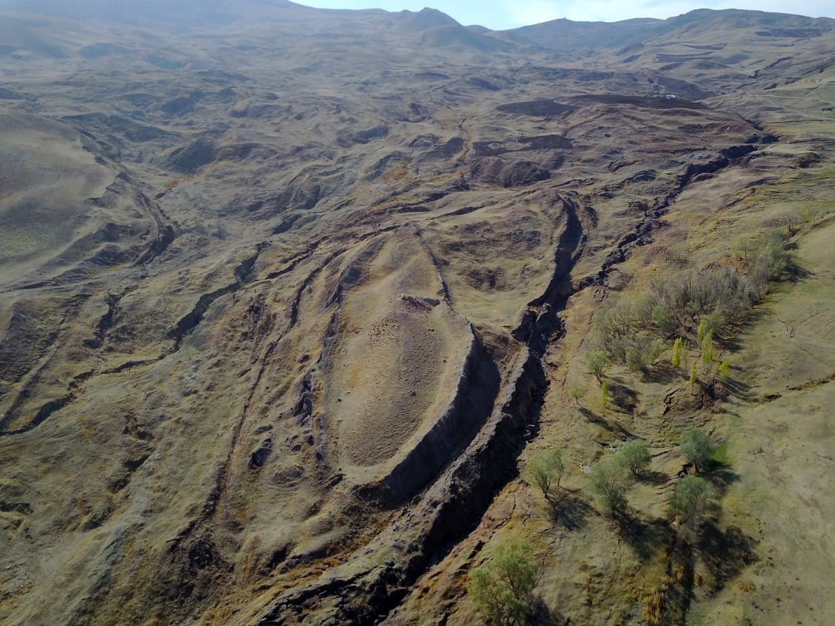

**Photo That Excites the World**

In August 1952, French Ferdinand Navarra climbed to 5000 meters in Ararat. Writer Yaşar Kemal is also in the group as a journalist. Nothing can be found. Yaşar Kemal sarcastically writes that the French are trying to make films and earn money. But Navarra does not give up. He comes back in 1953 and 1955. In 1955 he finds a 1.5 meter piece of wood. In Spain and France, someone says the age of the wood is 4 or 5,000 years old, but British scientists date the board from 700 BC and the Flood is not that recent. Meanwhile, Navarra tells about his experiences after his 1955 debut. (Source: Acta Geographica "L'Expedition au Mont Ararat".)

*“On August 14, 1955, after very difficult conditions, we reached 5000 meters. Where we were, there was a depth descending like a chimney. I tied a rope around my son Raphael's waist and hung it down. Then I descended with the help of the soldiers. When I landed next to the ship-like image from afar, I was disappointed. My son excitedly told me to take a piece of the ship. I showed him that it was the scum that came with the glaciers by telling him he was wrong. But Raphael told me to dig benath the scum and see what was in there. I had never thought about it. I dug a 0.5 m2 pit, 20 cm depth, with half an hour of effort. I came across a sheet of ice and broke it. There was water under it and a wooden beam tip that looked black inside. I touched it with my hand, it was really a board. It was a man-made board. I couldn't enlarge the hole any more, a tool was needed for this. I was able to cut a 1.5 meter piece In the end, after much effort. The water had no effect on this board.”*

Navarra's story resonated with people in Europe, but the traveler could not go any further.

**Natural Formation instead of Ship**

In 1958, a scientist in the USA, **John Libi**, fell on the road to Mount Ararat. There are also two well-known journalists, **Ümit Deniz** and **Ara Güler**, in the team. Libi disappears for a while and then is found, mishaps ensue during trekking. A turn is made from 5000 meters. Libi falls ill, disappears from his hotel in Ankara once again and the embassy cannot find him. The event is closed.

September 11, 1959. Map Officer Major **İlhan Duruppınar** captures an incredible image in the form of a complete ship while taking photographs of the region. According to the General Directorate of Mapping, photogrammetric maps have a ship-shaped relic. The picture is enlarged with a stereoplanigraph and it is understood that its length is 150 m. The photograph is sent to Professor **Arthur Branderburger** of Ohio University, USA, and the Professor approves. In the interview held after the photograph, which was given as a poster in Hayat Magazine at that time, Durupinar said,

*“…this is a shipwreck, but a ship that is thousands of years old will not stay the same. It is now a pile of stones. I do not listen to the myth of Noah and his Ark. On September 11, 1959, while observing the map around Doğu Beyazıt, I observed this shape. I think the lava was frozen by flowing in a pattern that was here before. Just as in Pompeii, even the facial expressions of the petrified people remained.”*

In 1960, Prof. Branderburger and **George Vandeman** from the **Washington Archaeological Research Institute** come to the mountain with Major Durupınar. Dimensions and picture are correct but no ship. The group is divided into two. While one group believes, the other group believes that this formation is natural. It is said that the excavations must continue, but it does not turn out.

**Moscow Complains**

In 1968, mountaineer **Alp Turhan Selçuk** climbed the mountain with 146 people, but returned empty-handed.

Whatever the reason, Navarra comes again in 1969 and finds five boards this time. According to the French, there is a Ship under 900000 m3 of ice.

Libi, who disappeared in Ankara in 1958, reappears in 1969. This time he finds fossils, but to no avail. Libi, who said he would come again, died in 1971.

In 1972, German researcher **Friedrich Bender** found 6,000-year-old tar woods, this time on Mount Cudi. Cudi is only 17 km from Şırnak and the region is full of beliefs and legends about the Flood and Noah. According to the belief, the Village of Eighties on the Mountain is the village founded by eighty people on the Ship. There are reliefs and inscriptions of Senherib on the mountain.

In 1973, Prof. J. Montgomery again makes a fruitless exit to Ararat. In 1974. Ağrı where the Mount Ararat is was declared a forbidden zone by the state and climbs were prohibited. According to one view, Armenian exploitation is behind the Ararat and Noah's Ark incident. Meanwhile, Pravda Newspaper, the official media of Moscow, writes that the USA went to Ararat for espionage. The CIA is behind the climbs. A political crisis ensues. The state ban tightens even more. Under these circumstances, Astronaut James Irwin appears, but returns to his hometown that year (1974) because he could not get permision. Irwin comes back in 1977 but still can't necessary legal permission to climd the mountain. Irwin's efforts will pay off five years later, as the country experiences a military coup circumstances. With the famous coup of September 12, 1980,for Türkiye James Irwin took the permission then from the President Kenan Evren.

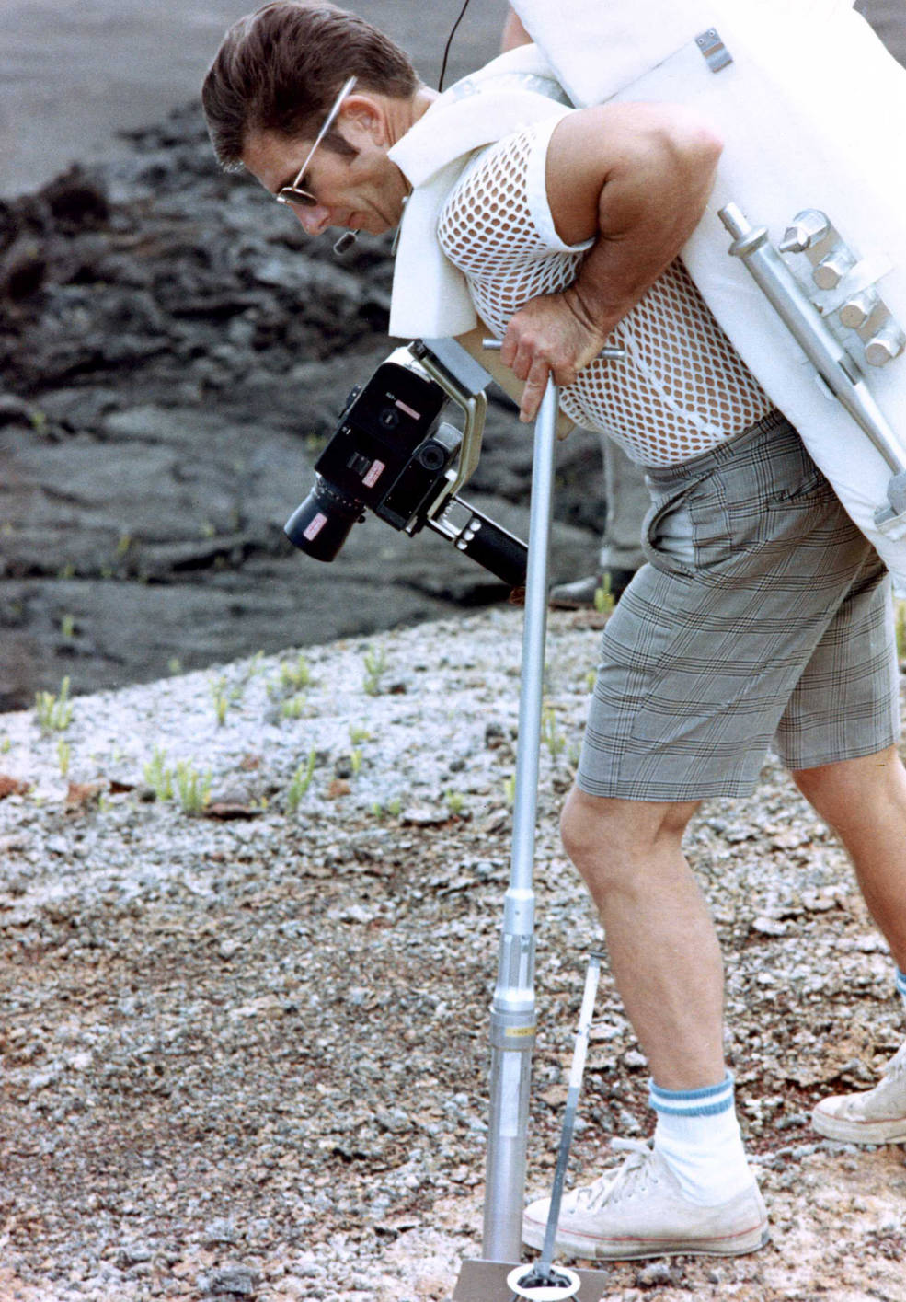

In the photo above, James Irwin, who was trying to collect soil samples in Hawaii, said in 1982 at an interview with Hayat (Life) , one of the popular magazines of the time.

*“I landed on the Moon and walked on the Moon. I brought samples of lunar soil, but none of them seem as important as the piece I will find in Ararat. On July 26, 1971, on Apollo 15, I set out for the Moon with two of my friends. After getting over the preparation and takeoff shock, we sat on the orbit. We were exhausted with excitement. My friends fell asleep. I felt like I had lost myself. It was like I was outside of myself. I was close to the 'Supreme Spirit' now. I thought I was suddenly thrown forward, but nothing happened. My friends were still sleeping and everything was fine. Suddenly I saw a very bright light from the window of the capsule. I have never seen such a light. It had all the colors pink, purple, yellow, green. I thought, 'Here he is. Then the light slid away. I suddenly realized that I was in a vacuum. I was out of my body and glided back to the vehicle and my own body that I saw before me. Three days passed and we landed on the moon. I was the first one to land and I was very excited. My head was aching. I was supposed to talk to Houston but I couldn't get my device to work. I was in despair and pain, but suddenly I was relieved. My headache had stopped. Suddenly I saw the light I had seen in space again. It was brighter and more eye-catching. And I was seeing Him again. Hz. It was Jesus. It was very beautiful and reassuring. I felt like he was talking in my head.* ***‘Why did we choose you? You are not the only one, you are one of them. There are others in the world who don't know each other like you. It wouldn't be believable if we chose someone unknown with the eyes of the world on you.'*** *He suddenly disappeared and at the same time I heard Houston's voice.”*

That's what Irwin said. According to his belief, finding Noah's Ark was a task for him. The next question of the reporter conducting the interview was important.

*"It is said that the astronauts who went to the moon had mental disorders and that's how you are."*

*"Lie. I have been to your country three times. I stayed for days, gave lectures. I talked to your head of state. On September 29, I spoke on television to 150 million people in the United States. This is the most interesting place in the world. Why not take advantage? Hundreds of individuals and organizations are waiting to invest millions of dollars. I think the discovery of Noah's Ark is the most important event of the age."*

**Kasım Gülek Appears**

Irwin had arrived with a group of 11 and his wife was his secretary. **Earl Cummings**, one of the founders of the High Flight Foundation, who had been to Ararat 14 times, was also in the team. After the lake at an altitude of 3000 m, they continued climbing. They had a letter in their hands. This letter was one of thousands of letters sent to the foundation. According to the description in the letter, they were going to see a relief of a bird holding a sword on one of the rocks, but they could not find it. They went on checking rocks. When they got to 4000 meters, they found nothing like a ship. Depressed, they returned to the camp. Among them was **Bob Staplich**, who had climbed the mountain before, and believed that he had seen the ship before. However, the place he described was the place described by Navarra, who described seeing the ship in the water in 1955. But it was located on the most dangerous side of the mountain. The Turkish mountaineer Yücel Dönmez, who was in the team, said that there were many claims about this issue, but that no one had seen a ship and that anyone who said they did was a liar. And then Bob couldn't find the place he said he had seen before.

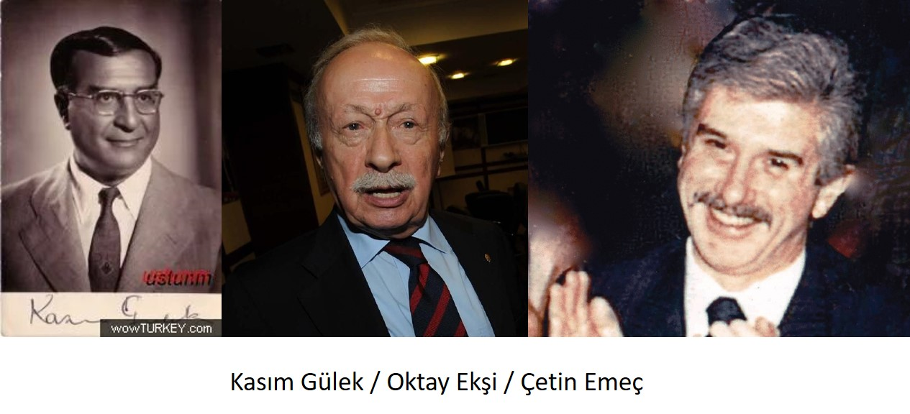

The next day, while out for a walk alone, Irwin fell and was found thirty hours later. He left Turkey after being transported to the hospital. But he came back in 1983. Even in 1984. This time Irwin *“We found it.”* said. What did he find? He had some stone and earth masses in his hand. All specimens disappeared while authorities had sought to examine them. What was going on? What was behind the search for Noah's Ark? Then an unexpected name appeared. Former CHP (Republican People’s Party) (MP – Member of Parliament) Kasım Gülek. It was heard that Irwin assistant Steffins and Kasım Gülek went to the USA. In the meantime, let's move on to the reaction of Journalist **Oktay Ekşi** (reputable former journalist) from his column, stating that a separate article should be written for Kasım Gülek (But not subject to this article)

*“What happens every year? Who are these missionaries?"*

However, no response came from anyone. This deafening silence in the face of questions reminded us of the usual insensitivity of those in charge.

**Çetin Emeç: *"The Urartians had gold mines on Mount Ararat"***

In 1984, again from the USA, **Dr. Willis** came with his own team and **John Morris**, the author of the book ‘**The Arc of Ararat’**, and they were in a hurry to g oto Ararat. Meanwhile, the famous archaeologist **Ekrem Akurgal** told the BBC, *"... there is something wrong with this. If the Flood is real, the waters cannot rise 1500 meters. There is no such geological finding, why didn't we examine it.”*. On August 31, 1986, Hürriyet newspaper wrote whether Irwin was a spy. It was said that a report was given to the prime minister on October 16, but its content was not disclosed. Irwin had been refused twice, but why did Kenan Evren, who took over the administration with the September 12 coup in 1980, give this permission? All these questions, as always, remained unanswered.

Now let's go back a bit, to 1978. At that time, Hürriyet's future editor-in-chief and press martyr **Çetin Emeç** was at the head of the history magazine "Yıllar Boyu" then, which had been published by Hürgün. In the editorial of the magazine dated October 7, 1978, Emeç asked:

*“We claim. There is gold in Mount Ararat. The Urartians were digging and extracting gold from Ararat 2270 years ago. Today, as the Soviet Union dug out of the mines that they opened on their side of the mountain… We do not break our mood, and we do not even wonder whether the tunnels opened by the Soviets exceed our borders. We dedicate our article to MTAE. (Offical Mining Institute of State)”*

The article had no effect and the result did not change. Who knows, maybe new bans were put in secret again by the government. This was the period after 1977 when Irwin could not get permission. After Irwin, there was no media movement or it was not heard. So whatever happened in the region was not announced to the press. Afterwards, there was the PKK in the region and an never ending war.

As a result, the ship cannot be on Mount Ararat. There are no traces of such a flood in geology. Might a Babylonian flood had passed in the Torah? In fact, the mountain is also unknown. Ararat or Cudi? It would not be wrong to think that there is an interest in the issue. Maybe the gold and silver that Noah or someone else loaded on the ark had been mentioned in Mesopotamian legends. The Urartian gold mines mentioned by Çetin Emeç, a uranium reserve, geopolitical importance, other unscientific purposes or something else. The only solution is to wait for real evidence to emerge. Maybe one day the cosmic joker will show us Noah's Ark. At that moment, humanity will encounter the first evidence of the mystical and mythological past. Are we surprised? It seems like there is not much left to surprise the people of the 21st century…